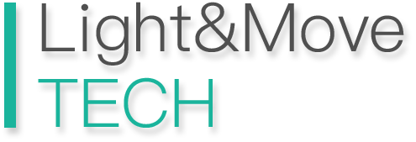
Light&Move Developer
SDK application form

Company Name
First name
Last name
email address
Phone number
Business type
( Neurology / Physics / Comprehensive )
Product type
( Brand Sales / Clinical / Treatment System )
Company website
Expected way of cooperation
( Distribution / Exclusive / System only )
Main market
( Country or Region )
Company Profile

Technology platform
( Android / iOS / Windows )
Application or system (Optional)
( URL / App name )

Agree to SDK Terms of Use
( Agree / Disagree )

View SDK Terms of Use:
https://www.lightmove.tech/download/SDKTerms_of_Use.pdf

Signatory
________________
Date of signing
________________

